**Assignment 16.1**

Here, we have the temperatures collected every minute, from 20 top buildings all over the world. For this data analysis, you can download the necessary dataset from the below link https://github.com/prateekATacadgild/DatasetsForCognizant/blob/master/Sensor%20data- 20161205T052506Z.zip In the above link there are two datasets; building.csv contains the details of the top 20 buildings all over the world and HVAC.csv contains the target temperature and the actual temperature along with the building Id.

HVAC (heating, ventilating/ventilation, and air conditioning) is the technology of indoor and vehicular environmental comfort. Its goal is to provide thermal comfort and acceptable indoor air quality.

Through the HVAC sensors, we will get the temperature of the buildings. Here are the columns that are present in the datasets: Building.csv – BuildingID, BuildingMgr, BuildingAge, HVACproduct,Country HVAC.csv – Date, Time, TargetTemp, ActualTemp, System, SystemAge, BuildingID ● Using Distributed cache join the two datasets and find out the number of temperature variations in each country using mapreduce.

**Driver class**

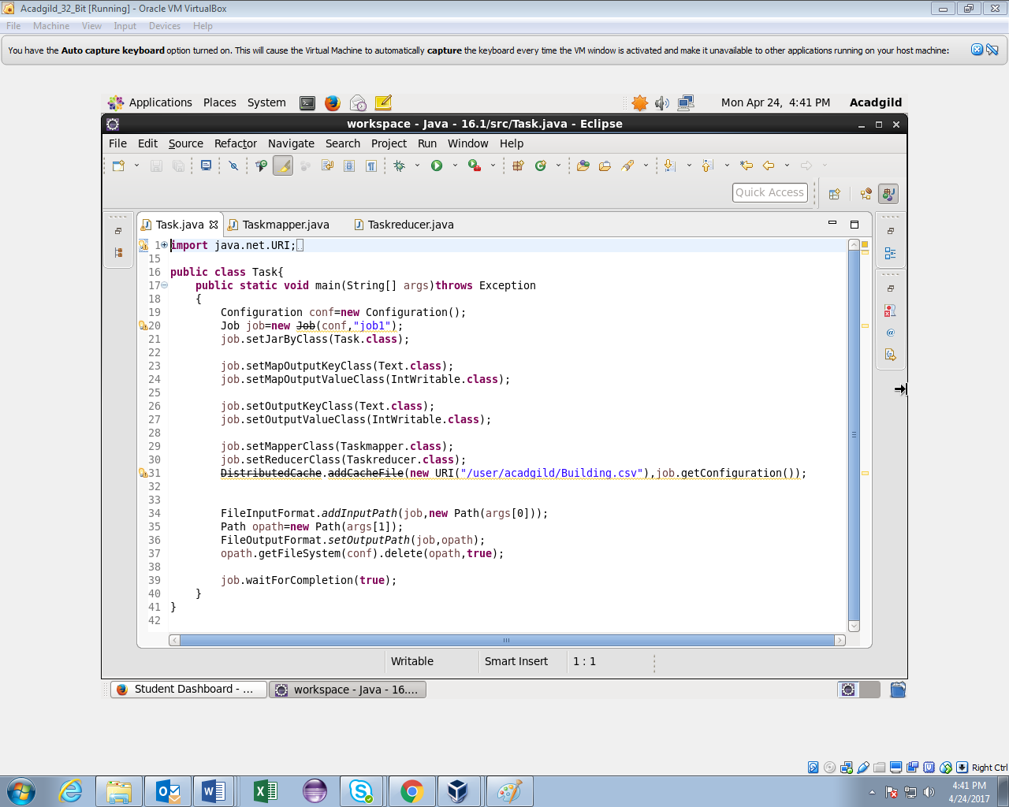

**Mapper class**

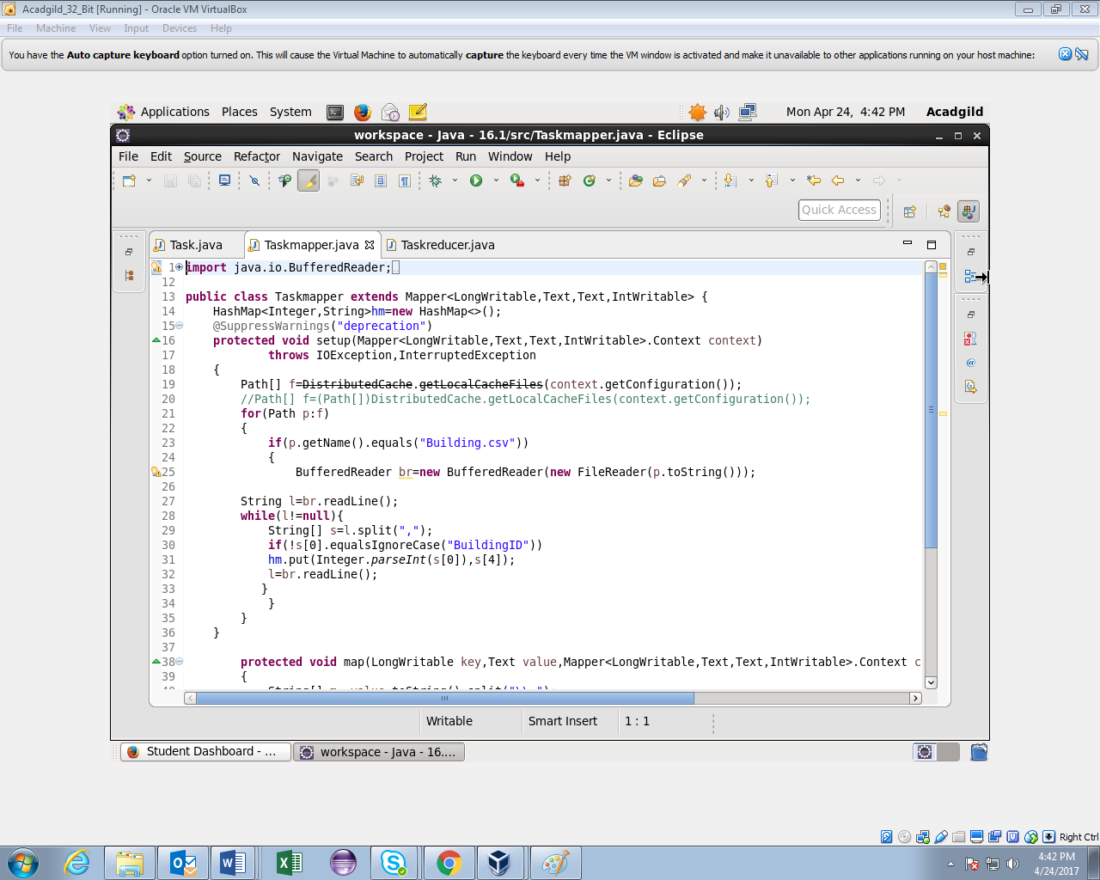

**Mapper class(contd..)**

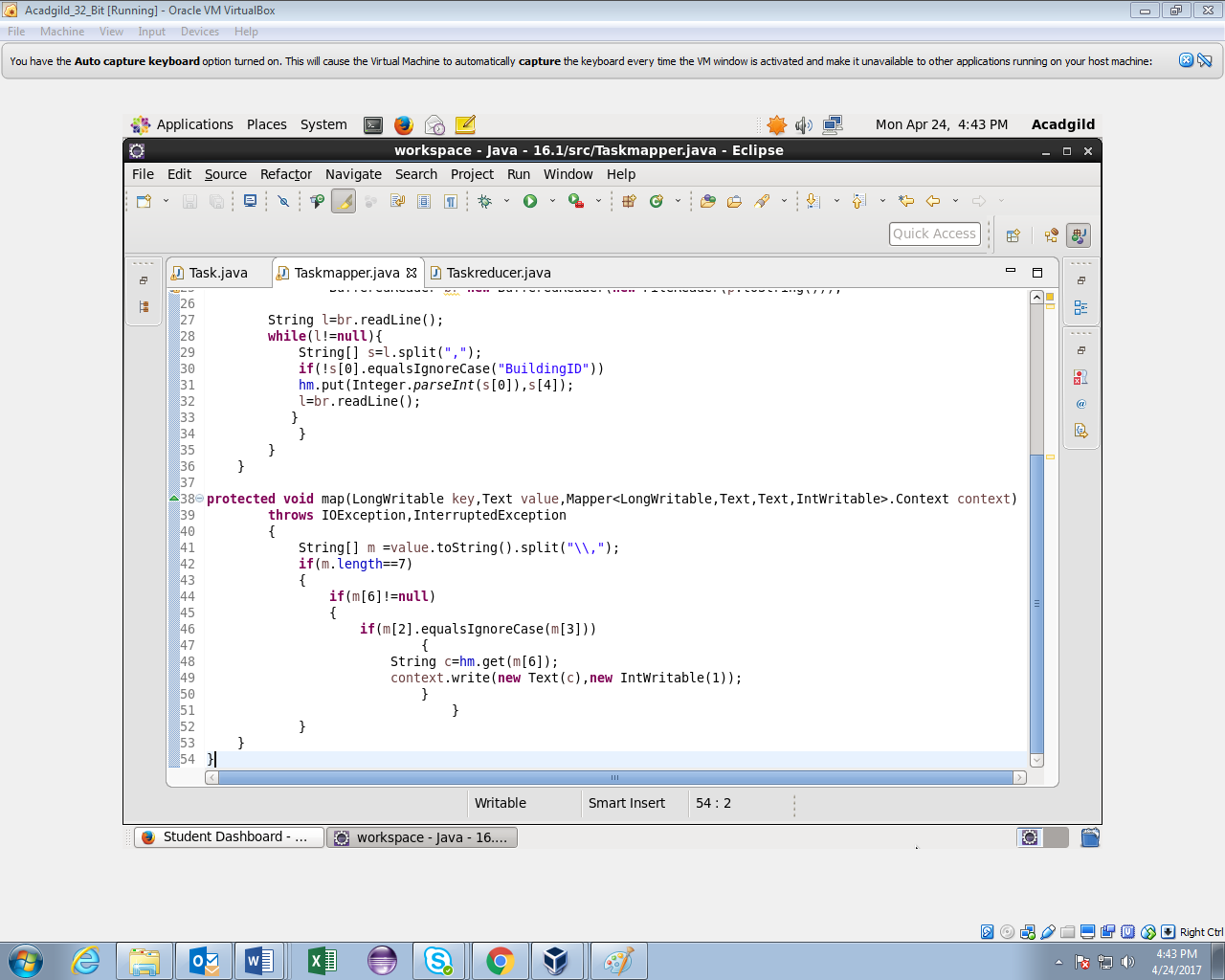

**Reducer class**

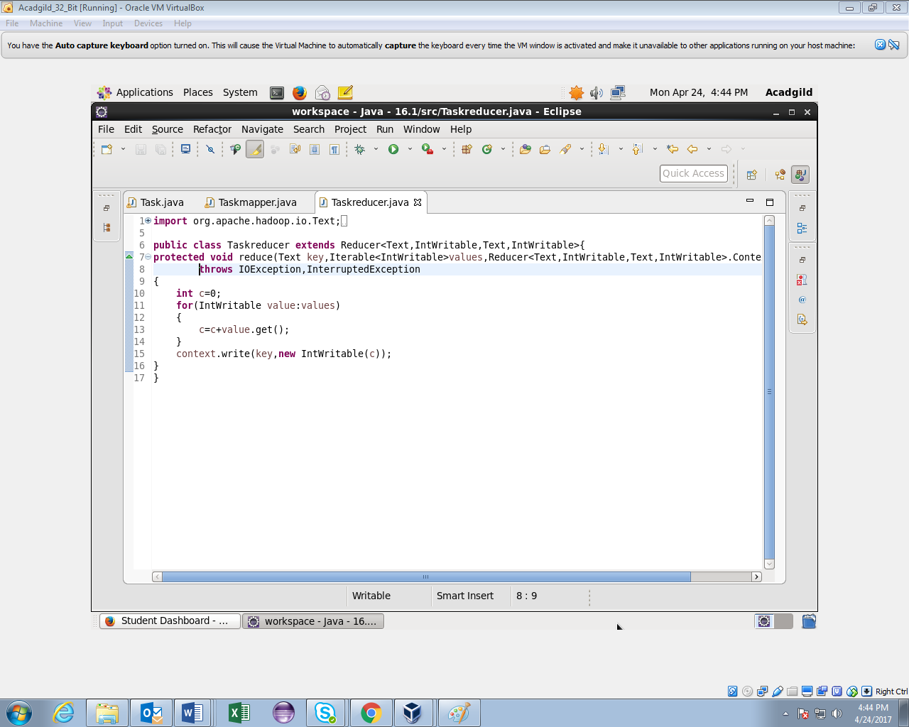

**Running jar**

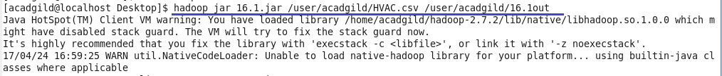

**Output**

